Hydropower Vision
Senior Design Group 15-08
Design Document Final

Students
Aldhaheri, Mohammed
Jones, Nicholas
Kraus, Kyle
Martinson, Josh
Tillema, Alex
Ward, Jared

Adviser
Prof. James D. McCalley

Client
Eduardo Ibanez (National Renewable Energy Laboratory)

Table of Contents

Project Overview……………………………………………………………………... 3
Problem Statement 3
Objective 3
Project Description 3
Definitions 3
Intended Uses 4
System Level Design………………………………………………………………… 5
Requirements 5
Technical Requirements
Business Requirements
Objectives and Approaches 5
Design Approach
Validation Approach
System Block Diagram 6
Region Identification Research 7
Develop Model (PLEXOS) 7
Identify Expansion 9
Overview…………………………………………………………………………………. 10
Deliverables 10
Economics 10
Restrictions and Challenges 11
Closure Materials……………………………………………………………………... 12
Conclusion 12
Project Schedule 12
Contact Information 12

Project Overview

Problem Statement

With the rising demand for electricity, there is an ever increasing need to reduce greenhouse gas emissions and improve the overall quality of our electric grid. Many of the resources that we are currently using are either non-renewable (e.g. fossil fuels) or cannot consistently guarantee generation (e.g. wind and solar). However, hydropower is renewable, consistent, and allows for greater manipulation of output compared to other renewable generation sources. Hydroelectric power has not seen many major developments in North America in the past few decades, leading to a large untapped potential.

Objective

Our objective is to coordinate with the US Department of Energy and the National Renewable Energy Laboratory to help develop a long-term “Hydropower Vision”. The goal of this vision is to establish an analytical basis for responsible growth in domestic hydropower, and become a major source in the renewable energy market.

Project Description

The project will give a detailed recommendation to the DOE Hydropower Vision. The recommendation will consist of many parts, the first being finding a prime location for Hydropower generation. This will then lead us to several other steps such as developing a power flow model and designing a new transmission line expansion.

Definitions

Midcontinent Independent System Operator (MISO):
MISO is an Independent System Operator (ISO) and Regional Transmission Organization (RTO) for the Midwest United States and Manitoba, Canada.

PLEXOS:
Energy Modeling Software used to develop power flows on an economic basis

Pumped Hydro (aka Pumped-storage hydroelectricity):
Pumped Hydro is a type of hydroelectric generation that stores water in an elevated reservoir and let’s it down to generate power when there is a high demand, and pumps water from a lower reservoir to act as a load when demand is low and/or other generation sources are overproducing (e.g wind and solar).

Department of Energy (DOE):
United States cabinet level department focusing on various kinds of energy.

National Renewable Energy Laboratory (NREL):
The primary laboratory for renewable energy and efficiency research and development.

Intended Uses

Our product is primarily intended to be used by the DOE and NREL in order to develop a long-term hydropower vision. It may also be used for research by many other organizations to help facilitate new research in many other areas.

Systems Level Design

Requirements

Technical Requirements:
In order for our project to be considered functional it must meet the following criteria:
- It must be implemented by the DOE and NREL as a useful tool to develop a new long-term hydropower vision.
- The report/power flow must be developed in a functional and easy-to-use fashion.
- Primarily, we must deliver a solution for each of the 5 objectives below

Business Requirements:
Although our project isn’t directly being used by consumers, there are a couple of non-functional requirements that it should meet:

- It should represent Iowa State students and faculty in a positive manner by being written and developed in a professional manner.
Approaches

Design Approach:
Our main approach for this design is looking at existing hydro-generation facilities and various studies to see how much the facilities cost, their effect on the power grid, and their impact on the surrounding environment.

Validation Approach:
The primary source of validation for our work will be Professor McCalley. This will be done by keeping him updated on the progress of our project, so he can provide sanity checks on our various models and what we extrapolate from research.

System Block Diagram
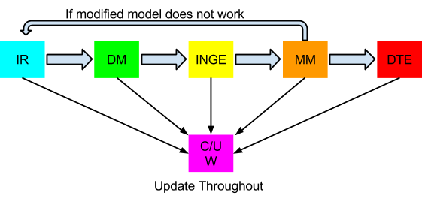
Figure 1: Hydropower Vision System Block Diagram
Identify Region (IR)
- In order to determine the best possible region for hydropower, we looked at a variety of locations, using research from a multitude of sources. After much discussion we decided that the Manitoba region in Canada was our best option.
Develop Model (DM)
- After much discussion with our adviser and other sources we determined that we will be using either a 13 or 62 node model using PLEXOS modeling software. This will allow us to accurately predict the responses to the grid when developing additional hydropower in the Manitoba region.
Identify Non-hydro Generation Expansion (INGE)
- Look for other generators that are likely to be put in place in the identified region.
Modify Model (MM)
- Add both the new hydro and non-hydro generators to the previously developed power flow model.
Design Transmission Expansion (DTE)
- Design transmission line expansion to connect new generation sources to the existing system.
Create/Update Website (C/U W)
- Use website to document all progress on the project.

Region Identification Research
This process initially involved looking at possibilities for hydropower expansion primarily in the US. There were many considerations that we took into effect such as environmental concerns, potential MW capacity, population displacement, type of available hydropower, projected long-term plans, and many others. After narrowing our options down to Colorado, Missouri, and Pennsylvania through collaboration with our advisor and the DOE, we realized there was the option to look into trading with Canada as well. This led to another week of hard research and after careful analysis, the Manitoba region in Canada was the clear choice. It offers the most available capacity, but with a lot less restrictions.

Develop Model (PLEXOS)

PLEXOS is a very powerful tool that requires a lot of training and knowledge in order to make our model work properly. For this reason, we have dedicated 1-2 people of our group to understand this software. We will be using many resources in the departments such as tutorials and graduate students knowledgeable in the program to accomplish this. An example of a gas PLEXOS power flow can be seen below.
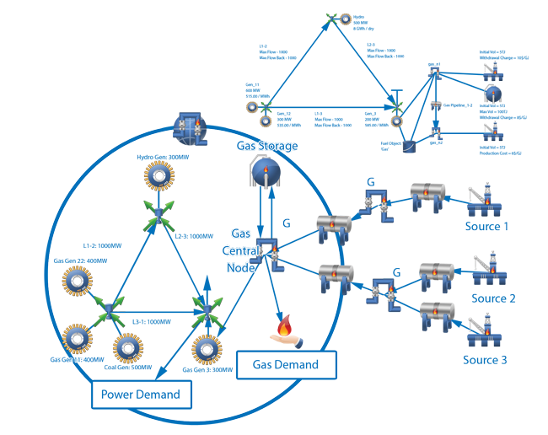

After many challenges, we were able to create a power flow that modeled the existing power system as is. This system is broken down into 13 nodes and represents power primarily being transmitted within the United States. Data from Manitoba will be implemented the following semester when we finish our 4th objective, which is to create the power flow with hydropower expansion. Some examples of the PLEXOS modeling software can be seen below.

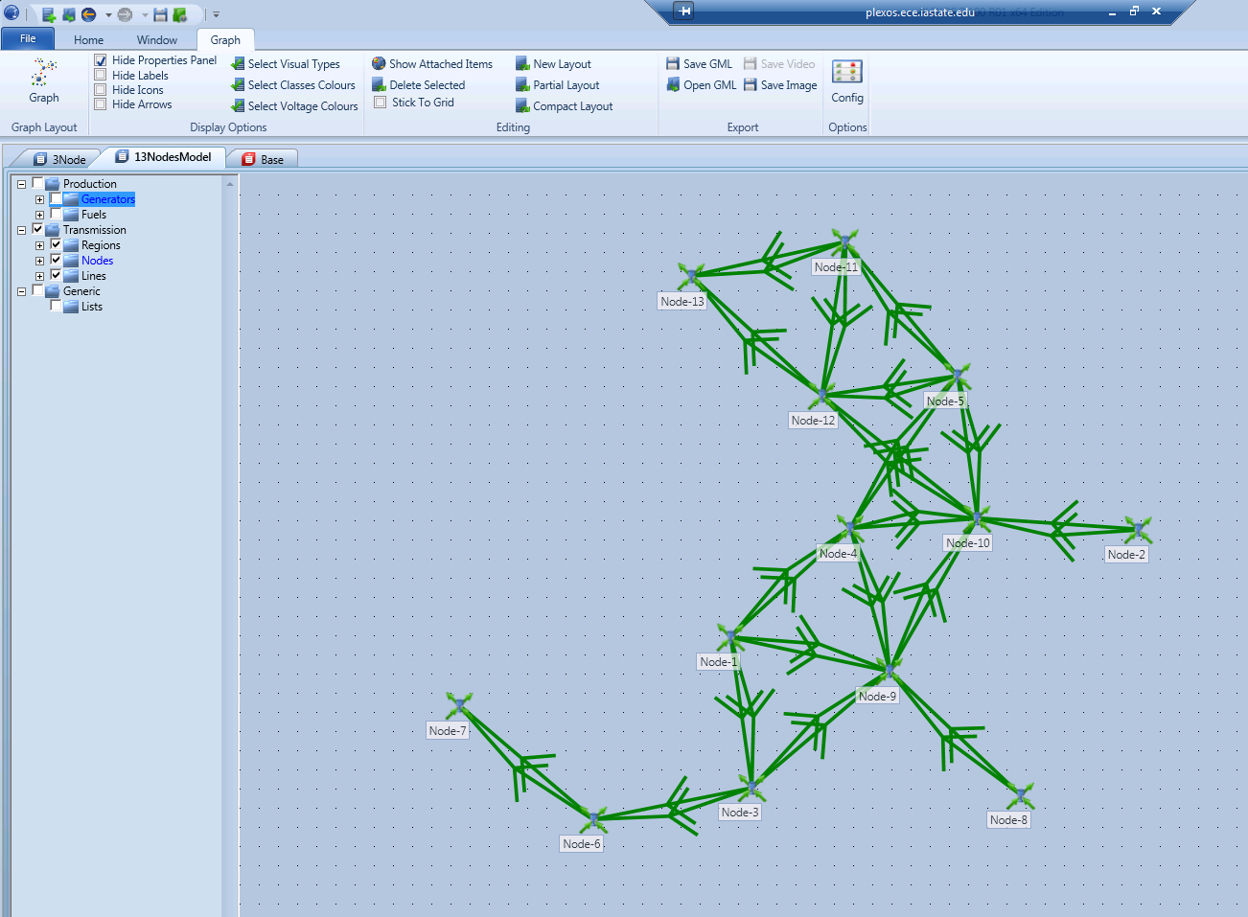
13 node model
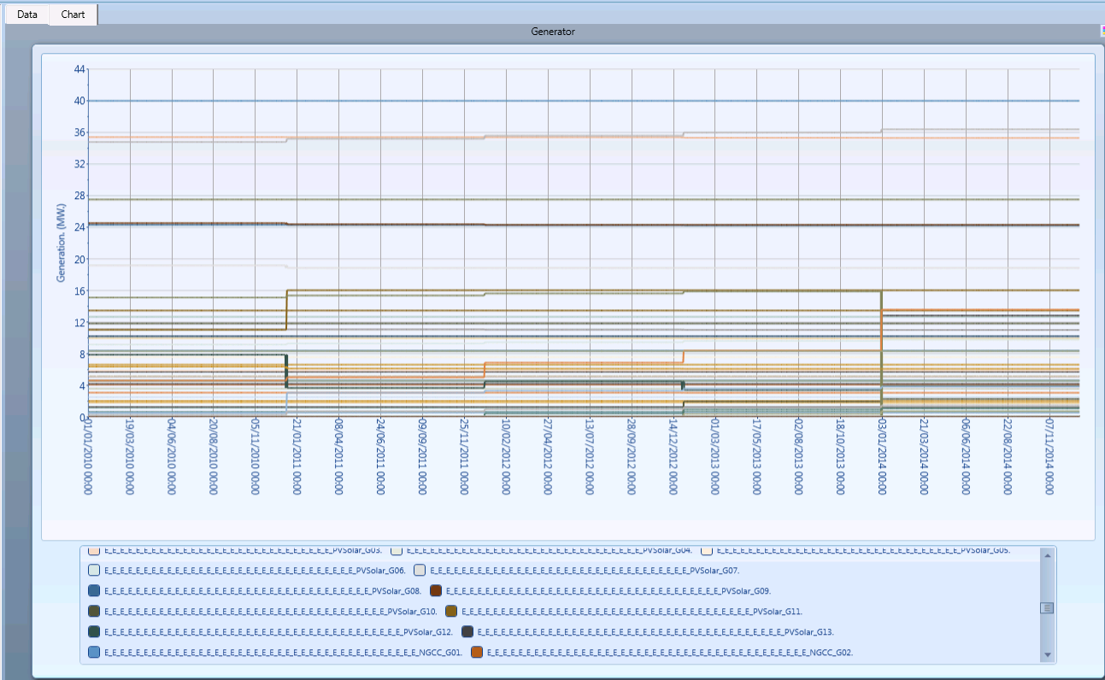
Medium-term power flow model

Identify Expansion
Manitoba is the identified region. With over 98% of their electricity being generated through hydropower, an expansion in this region would be most beneficial for their export market. As you can see from the figure below, there are several options for more hydropower generation in this region.
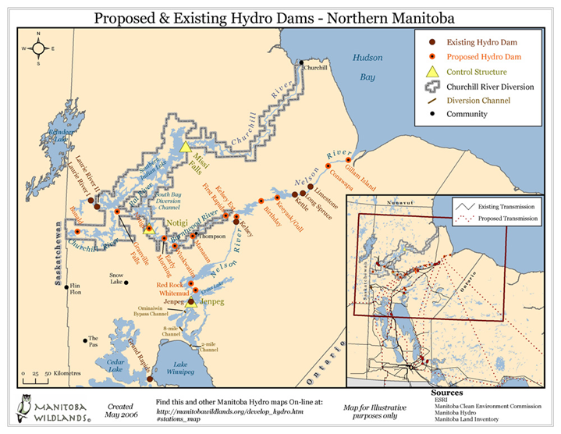

However, there are also other generation sources that we may need to take into account in order to properly develop our future power flow model. With thermal, natural gas, and wind energy being a large part of the electricity market, there will most likely be expansion in this area as well as the MISO region. Data is still being collected and organized but it will be implemented within our power flow from the 4th deliverable.

Overview

Deliverables
Our project has 5 main deliverables that we need to successfully complete in order for our system to be successful. These include:
- Identify a region in the U.S. or Canada that would be best for new hydropower resources.
- Obtain or develop a power flow model of the existing electric system.
- Identify likely non-hydro expansion in the system.
- Modify model to include our suggested hydro region and other non-hydro expansions.
- Design a transmission expansion to accommodate hydropower in our chosen region.

Economics
One of the key aspects in implementing our design is to understand the economics of adding additional hydropower into the grid. This is because nothing ever gets built unless it makes sense economically. For example, in a study done by MISO, they analyzed the benefit to cost ratio for developing new hydro in the Manitoba region.
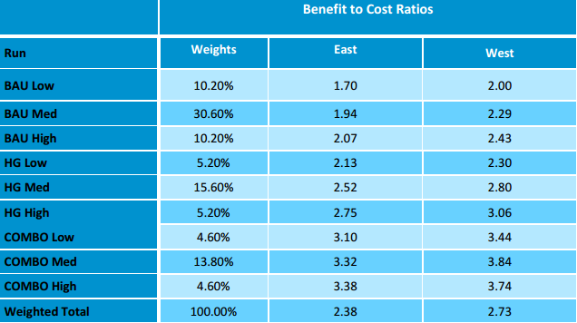
Table: Benefit to Cost Ratios
The descriptions the left side correspond to possible scenarios regarding additional transmission with these abbreviations, where low, medium, and high correspond to possible levels of water availability in the region:
- Business as Usual (BAU)
- Historic Growth (HG)
- Combined Policy (COMBO)

As you can see, all values for the ratios are >1, so initially it seems to make sense economically.

Restrictions and Challenges
There are several restrictions and challenges that we may face in creating a power flow and completing our project. However, two of the restrictions that we plan on being most prevalent in developing a power flow are in regards to creating transmission lines and ability to accurately model these transmission lines.

For example, as you can in the figure below, we have a couple of possibilities in regards to areas to create new transmission lines connecting to the Manitoba region. These might make sense theoretically, but there are even more restrictions to building these lines such as environmental impacts, cost allocation, international trade, and many others.
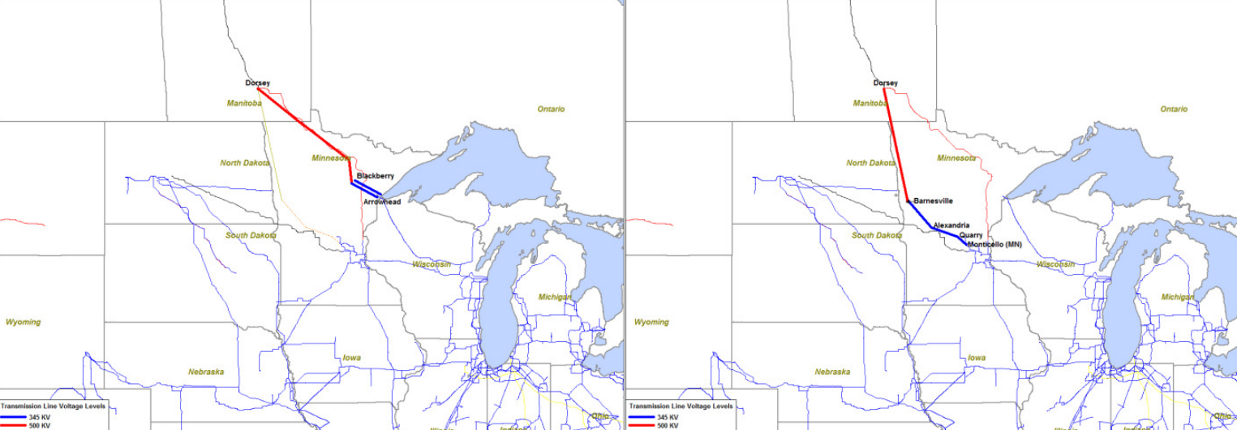

Figure: Possible transmission line expansions to Manitoba

The other restriction mentioned relies upon being able to accurately model these transmission lines with PLEXOS and connect them to previous nodes. Although PLEXOS would be more than capable to complete this task, a lack of a data set and information may be the biggest hurdle.
Closure Materials

Conclusion
While this project poses many obstacles, we will complete all of our objectives and make our best suggestion to the DOE and hopefully it will be implemented in the future. Allowing for even more growth in renewable generation in the Midwest and Canada.

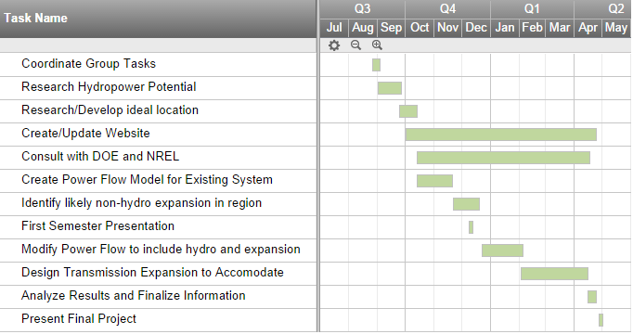
Project Schedule
Contact Information
Our group for this project consists of 6 team members. Every team member was designed a specific role based on our strengths and weaknesses in order to maximize our overall productivity. We decided to implement the roles as follows:

Aldhaheri, Mohammed: Lead Researcher mohammed@iastate.edu
Jones, Nicholas: Communication Leader nmjones@iastate.edu
Kraus, Kyle: Webmaster kckraus@iastate.edu
Martinson, Josh: Key Concept/Webmaster jlogan@iastate.edu
Tillema, Alex: Team Leader atillema@iastate.edu
Ward, Jared: Key Concept Leader jarawar@iastate.edu

